Worded Circle Questions

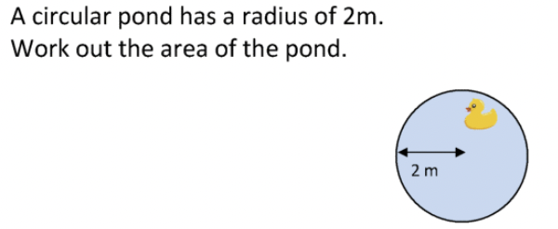

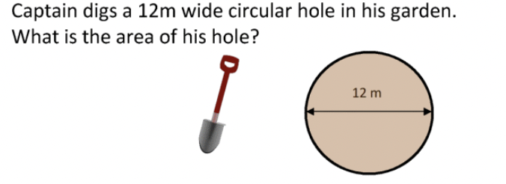

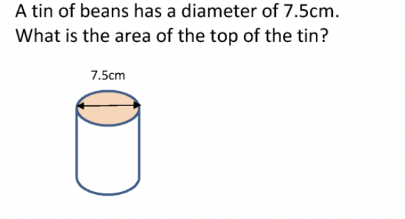

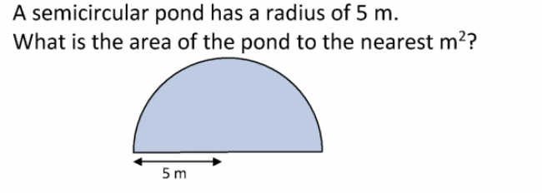

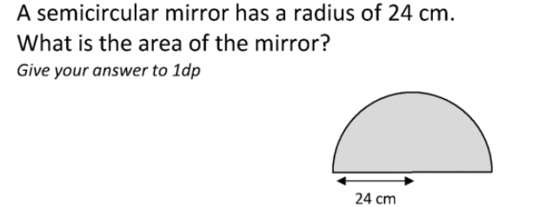

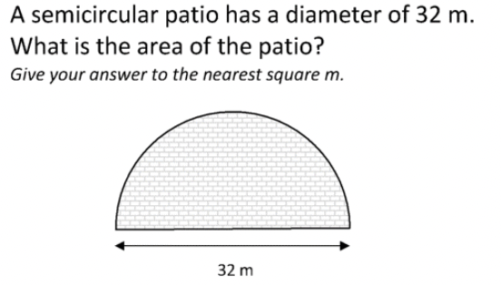

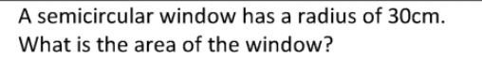

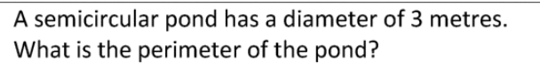

- A circular mat has a diameter of 53 centimeters. Lily wants to sew a decorative braid around the mat. How many centimeters of braid does she need? Give your answer to the nearest tenth of a centimeter. Use 3.14 as an approximation of π.

- A metalworker cuts out a large semicircle with a diameter of 28 centimeters. Then the metalworker cuts a smaller semicircle out of the larger one and removes it. The diameter of the semicircular piece that is removed is 14 centimeters. Find the distance around the shape after the smaller semicircle is removed.
